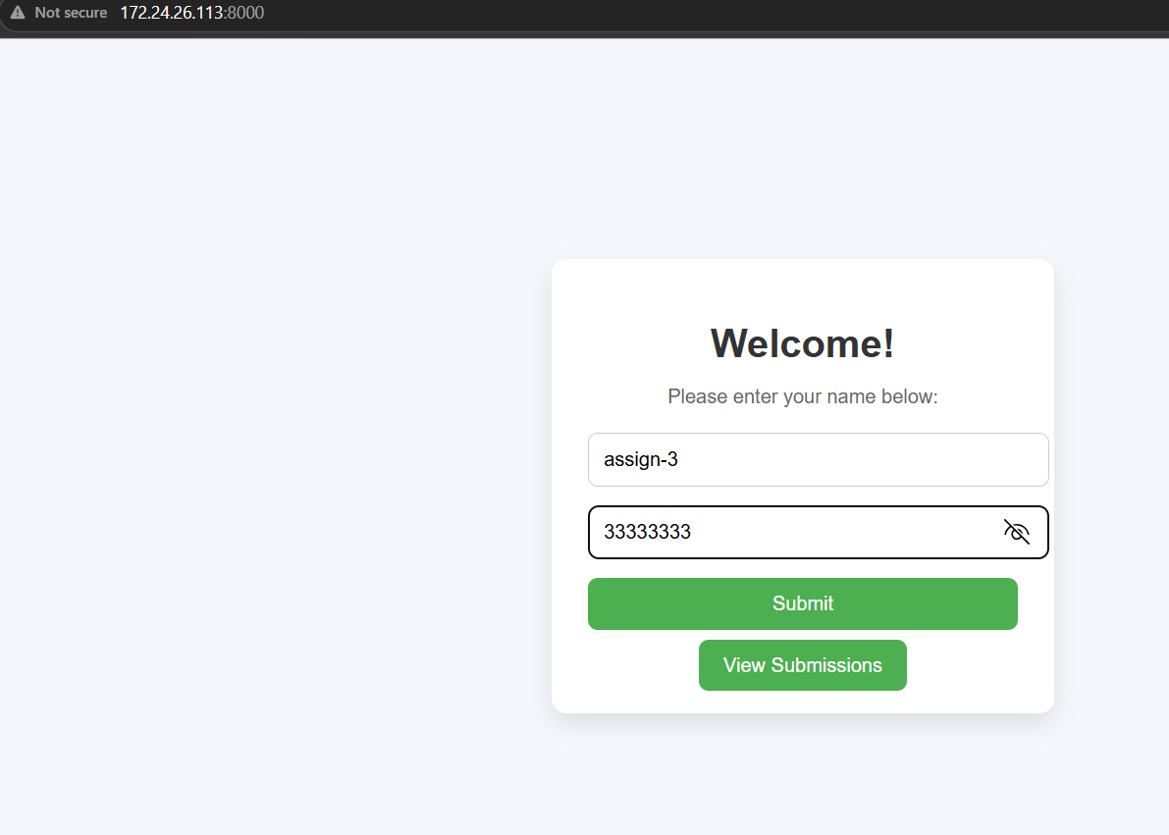

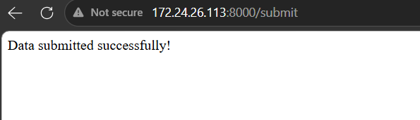

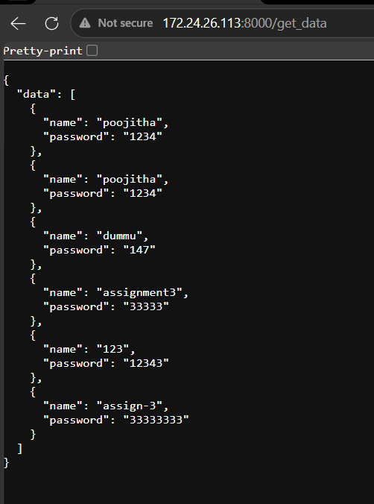
GITHUB repo link: https://github.com/poojithachithari/Basic_Flask_MongoDB_Application

